Write a Custom User Store Listener

Introduction
WSO2 Carbon user stores provide the ability to customize user store operations by registering an event listener for these operations. The listeners are executed at a fixed point in the user store operation, and the users are free to create a listener that implements their desired logic to be executed at these fixed points. A listener is an extension to extend the user's core functions. Any number of listeners can be plugged into the user core and they would be called one by one. By using a listener, you are not overriding the user store implementation, which is good since you are not customizing the existing implementations.

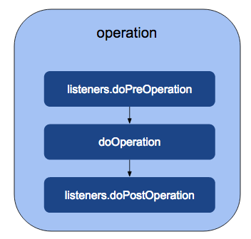

The above diagram demonstrates a typical flow of execution of the user store operation, along with the listener's methods.
The flow is as follows.
- Initially, the operation method (here, representative of any user store operation) calls the listener.doPreOperation, which is implemented in the listener.
- Then, the doOperation method is called, which is implemented in the subclass by extending org.wso2.carbon.user.core.common.AbstractUserStoreManager, the abstract class that implements the UserStoreManager interface.
- Finally, the listener.doPostOperation method is called.

How listeners work

Whenever the user core method is called, all the listeners that are registered with that method are called. Listeners can be registered before or after the actual method is called.

Sample scenario
When a user is authenticated with an LDAP, assume that it is a requirement to add the authenticated time as a user attribute. To fulfill this requirement, you need to write some custom code to be executed after successful user authentication. The following is the custom listener implementation for this. The doPostAuthenticate() method would be called after actual user authentication is done.

Write a custom listener
Follow the steps given below to write a custom user store listener. Please note that there are high level instructions on what you need to follow to add a custom listener. A complete implementation blueprint can be found here.
- To write a new listener, you must extend org.wso2.carbon.user.core.common.AbstractUserOperationEventListener.
package org.wso2.custom.user.store.listener;

public class MyCustomUserStoreListener extend AbstractUserOperationEventListener {

- Override the getExecutionOrderId() method to return any random value.
This is important when there is more than one listener in WSO2 IS and you need to consider their execution order. All the methods return a boolean value. This value is mentioned regardless of whether you want to execute the next listener or not.
@Override
public int getExecutionOrderId() {
return 9883;
}

- Override doPostAuthenticate() method. This method would be called after actual user authentication is done. For now let’s add some logs to test if the implementation works as expected. Later on you can custom logic according to your requirement.
@Override
public boolean doPostAuthenticate(String userName, boolean authenticated, UserStoreManager userStoreManager) throws UserStoreException {

// custom logic

// check whether the user is authenticated
if(authenticated){
log.info("=== doPostAuthenticate ===");
log.info("User " + userName + " logged in at " + System.currentTimeMillis());
log.info("=== /doPostAuthenticate ===");
}

return true;
}

- Register the event handler.
The event handler needs to register in the service component as follows:
Package org.wso2.custom.user.store.listener.internal;

@Component(name = "custom.user.store.listener.component",
immediate = true)
public class CustomExtensionServiceComponent {

private static final Log log = LogFactory.getLog(CustomExtensionServiceComponent
.class);

protected void activate(ComponentContext context) {

MyUserStoreCustomListener listener = new MyUserStoreCustomListener();
context.getBundleContext().registerService(UserOperationEventListener
.class.getName(), listener, null);
log.debug("My Custom bundle is activated");
}

Prerequisite
- A Wso2 Identity Server setup.
- Please verify that all the system requirements are satisfied.
- An Application registered in Identity Server.
- An application deployed in Tomcat server.
Ex: pickup-dispatch application

Set up
The existing implementation of a custom user store listener can be downloaded from here.
- Listeners are registered as OSGi components. Therefore you need to register this class in an OSGi framework. Implementation details can be found here.
- Clone wso2/samples-is repository and navigate to user-mgt/custom-user-store-listener directory.
cd event-handler/custom-identity-event-handler

- Run the following command:
mvn clean install

- Copy the generated jar file into the <IS_HOME>/repository/components/dropins directory.
- Restart the server.

Try it

- Go to the homepage of the registered application.
ex: http://localhost.com:8080/pickup-dispatch
- You will be redirected to the authentication portal as shown below. Add user credentials.
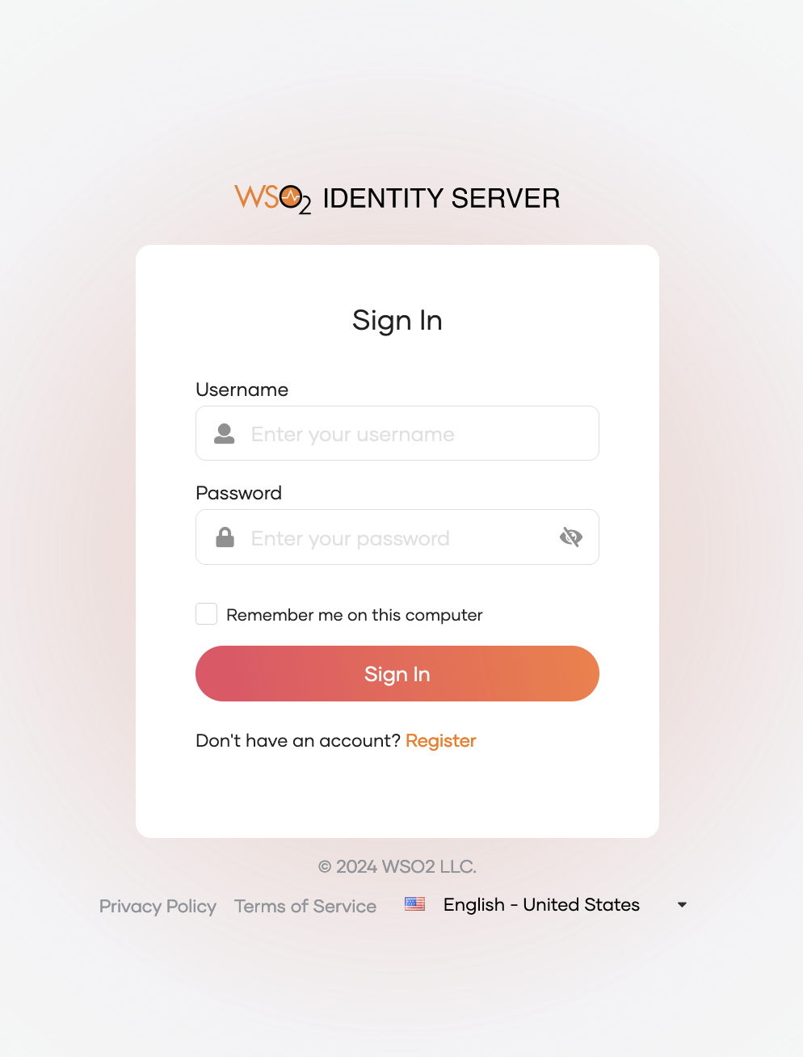

- After a successful authentication, the below logs can be found in the IS server logs.
